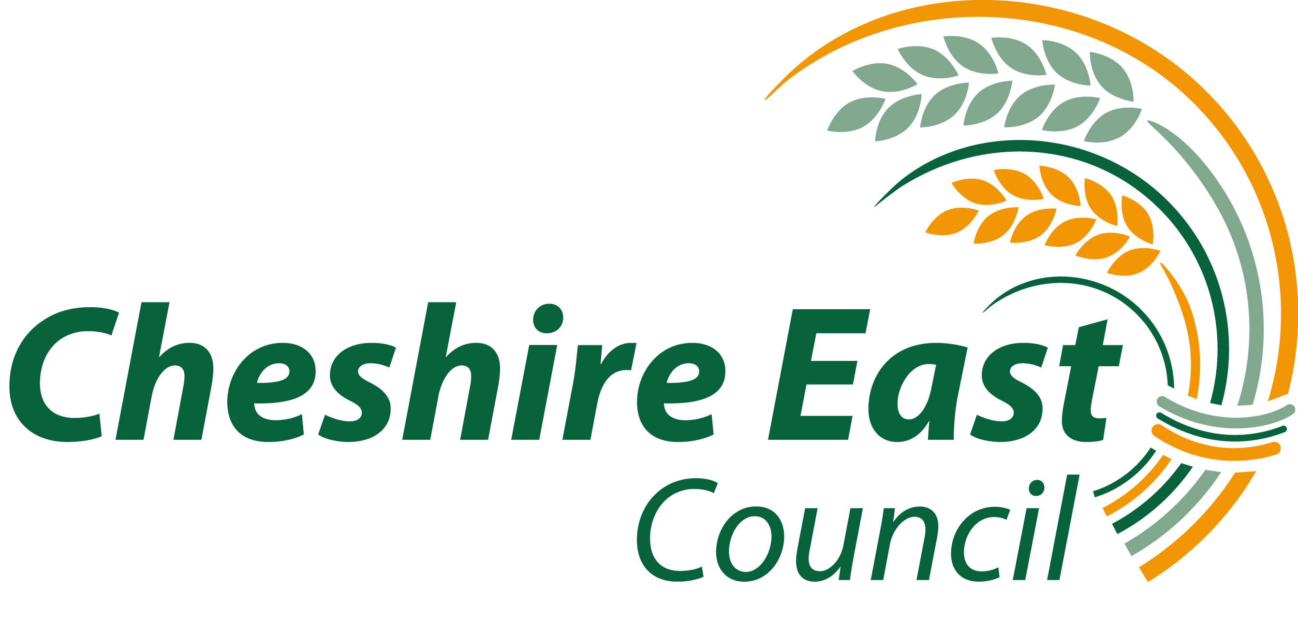

CHESHIRE EAST DISABLED CHILDREN’S DATABASE

Registration Form

The Cheshire East Disabled Children’s Database (DCD) is a voluntary register for children and young people with a disability aged 0-18 years and living in Cheshire East.

The benefits of being on the Database:
- be kept informed and up to date about services and activities in Cheshire East for disabled children and young people and their families through our contact list and the Children With Disabilities Short Breaks Team
- have a voice through consultation and surveys to influence planning for the needs and demands for services in Cheshire East

The information you give us is important as it helps us to plan and monitor services.

Information given on this form will be seen and used by Cheshire East Council staff and treated as confidential. All data is held securely and in compliance with the Data Protection Act 1998. We will keep the details on this form on our database so that we can keep you in touch by post, phone and email. We will not share personal information with any other organisation.

Please post or email the completed form to:

DCD  CWD Short Breaks Team  Floor 1  Macclesfield Town Hall  Unicorn Gateway  SK10 1EA | Tel: 01625 378083  Email: Shortbreaksteam@cheshireeast.gov.uk

If you would like this document in larger print or in another format please contact us.
The term ‘child’ on this form refers to ‘child’ or ‘young person’

ABOUT YOUR CHILD

Child’s Surname: ___________________Child’s First name(s): _______________

If your child has been known by any other name, please give details:

Surname: ____________________First name(s): ___________________________

Male Female: Date of birth: ___________________________

Child’s address – this is where postal information will be sent _____________________________________________________________________

_____________________________________________________________________

Post code: ____________________Telephone number: ______________________

Cheshire East Council Equality and Diversity Monitoring:

Child’s Religion ________________________

Child’s Ethnic group
Please tick the box that is closest to your child’s ethnic background

African |  | White British
Caribbean |  | White Irish
Any other Black background  Give details |  | White and Asian
 |  | White and Black African
Bangladeshi |  | White and Black Caribbean
Indian |  | Any other White background  Give details
Pakistani |  | Any other White background  Give details
Chinese
Any other Asian background  Give details |  | Gypsy/Roma
 |  | Traveller of Irish heritage
Any other Mixed background  Give details |  | I do not wish to answer

Your child’s disability and diagnosis

Please tick and underline those that apply and add further details where appropriate

If you would like some advice and help with this section, or any other part of this form, please do not hesitate to ask any of the professionals you have contact with or contact the CWD Short Breaks Team on 01625 378083, or email: Shortbreaksteam@cheshireeast.gov.uk

DISABILITY/DIAGNOSIS | √
A diagnosis of an Autistic Spectrum Disorder
including: Autism and Asperger syndrome

Behaviour
including: Social and Emotional difficulties, ADHD / ADD

Communication
including: speech and language disorders

Developmental Delay
developmental difficulties with no formal diagnosis

Sensory impairment
please give brief details of impairment:

Learning
including: moderate or severe learning difficulties, Dyspraxia

Mobility Difficulty/ Physical Disability
please give brief details:

Long term chronic illness
Please give brief details:

Syndrome / Chromosome disorder
name/type:

Other condition not mentioned above
please give details:

Child’s Education
Yes No
Does your child have an Education, Health and Care Plan?

Name of current playgroup/nursery/school/college _________________________

A child does not need to have a Statement of Special Educational Needs or an Education, Health and Care Plan to be on the Disabled Children’s Database

PARENT(S) / CARER(S)
Information will be sent electronically where possible

(1)Title: _________________

Surname: ______________________First Name(s): __________________________

Relationship to child: __________________

Address (if different from child’s on page 2): ________________________________

_____________________________________________________________________

Post code:_________________ Tel no:____________________________________

Mobile: ___________________ Email: _____________________________

(2)Title: _________________

Surname: ______________________First Name(s): __________________________

Relationship to child: __________________

Address (if different from child’s on page 2): ________________________________

_____________________________________________________________________

Post code:_________________ Tel no:____________________________________

Mobile no: _________________ Email:______________________________

CONSENT FOR REGISTRATION
(to be completed by parent/carer)

I agree to my child’s name being included on the Cheshire East Disabled Children’s Database

Signed: _____________________________ Date: ____________________

Name: ________________________________________________________

This form is acceptable with only your name and date if it is being completed electronically

For statistical purposes please let us know where you found out about the Disabled Children’:

School/ Health centre/GP Hospital/Paediatrician

Nursery

CEFS Social Worker Short break provider

CAMHS Children’s Centre / Cheshire East Children with

Early Years Support Disablilities Short Breaks Team

Other

Please specify:

November 2017

